A Minor Project Final Report on

# Student attendance system using QR code

Submitted in Partial Fulfillment of the Requirements for The Degree of BE.IT(6thsem) under Pokhara University

**Submitted by:**

**DISHAN SHRESTHA, 181409**

**PAWAN THAPA, 181421**

**RAJKUMAR BISHWAKARMA, 181427**

Under the supervision of

**ANKIT KHAREL**

Date:

# 1-Nov-2022



**Department of IT Engineering**



**ACKNOWLEDGEMENT**

We would like to convey our deep appreciation to our Supervisor Ankit Kharel for his

valuable suggestions and guidance in the completion of our project. We would also like to

express our gratitude to Er. Madan Kadariya, Head of Department of IT Engineering for

providing all the required facilities and information to accomplish our assignment.

Moreover, we express our heartfelt gratitude to our teachers, classmates for their coordination

during this period even while facing a pandemic.

Dishan Shrestha

Pawan Thapa

Rajkumar Bishwakarma

Nepal College of Information Technology

Balkumari, Lalitpur, Nepal

# ABSTRACT

In this era of technology, smartphones play a significant role in our day-to-day life. Nowadays smartphones can solve most of the problem very quickly and easily. It has made life of every person simple and easier with different social app, commercial app, problem solving app, app for education and marketing etc. Followed by the technology the paper purposed a system that will handle a problem for recording the attendance. The proposed system is a mobile application, for generating the QR Code by teacher which is then scanned by student and generating the attendance in XLS format. The paper discusses how the system verifies student identity to eliminate false registrations. The system deals with the management and evaluation of attendance of all students. The teacher QR code will be provided to students for giving attendance. The professor handling the subjects is responsible to mark the attendance for all students of the group or class. The attendance will be marked as 0 and 1, 0 for absent and 1 for present in the database of the particular student row in the table. The student attendance reports will be generated in XLS sheet for further use.

Keywords: QR, attendance, system, teacher, student.

# TABLE OF CONTENTS

ACKNOWLEDGEMENT………………………………….……………………ii

ABSTRACT…………………………………………………………………......iii

1. INTRODUCTION……………………………………………….……………….1
2. PROBLEM STATEMENT………………………………………….……………1
3. OBJECTIVES………………………………………………………….…………2
4. PROJECT SCOPE AND LIMITATIONS…………………………….………….2
5. SIGNIFICANCE OF STUDY……………………………………………………2
6. LITERATURE REVIEW………………………………………………………...3
7. METHODOLGY………………………………………………………………....4

7.1 Software Development Life Cycle……………………………………………4

7.1.1 Requirement Analysis……………………………………………………....4

7.1.2 Design Phase………………………………………………………………..5

7.1.3 Coding Phase………………………………………………………………. 5

7.1.4 Testing Phase……………………………………………………………….6

1. SYSTEM AND UML DIAGRAMS……………………………………….……..7

8.1 Context Diagram……………………………………………………….……..7

8.2. Use Case Diagram…………………………………………………….……..8

8.3 System Sequence Diagram…………………………………………………..11

8.4 Sequence Diagram…………………………………………………………...17

8.5 Activity Diagram………………………………………………………….…18

1. TOOLS AND TECHNIQUES………………………………………………..…20
2. USER INTERFACE………………………………………………………..……21
3. TIME SCHEDULE………………………………………...……………………24
4. CONCLUSION………………………………………………………………….26
5. REFERENCES…………………………………………………………….…….26

**LIST OF FIGURES**

Figure 1: Incremental model of software development lifecycle ......................................................4 Figure 2: Data Flow Diagram ............................................................................................................7 Figure 3: Use Case Diagram...............................................................................................................8 Figure 4: SSD for Creating an account' ............................................................................................11 Figure 5: SSD for managing student details......................................................................................12 Figure 6: SSD for ‘managing subject details.....................................................................................13 Figure 7: SSD for generating QR code'..............................................................................................14 Figure 8: SSD for ‘Taking attendance’..............................................................................................15 Figure 9: SSD for ‘Generating report’...............................................................................................16 Figure 11: Sequence Diagram............................................................................................................17 Figure 12: Activity Diagram..............................................................................................................18

**INTRODUCTION**

Among the various types of attendance systems that have been developed, using punch cards, log books, fingerprint systems, barcodes still cause lots of problems such as providing incorrect information to the users. The purpose of the smartphone-based attendance system is to computerize the traditional way of recording attendance and provide an easiest and smart way to track attendance in institutions nowadays, the most common device that have been come into account in marketing and business are smartphone devices. Moreover, it comprises lots of them running Android OS.

# PROBLEM STATEMENT

The main reason behind developing this project is the problems which were faced by the people.

* Manual system is time consuming.
* Risk of misplacing the paperwork.
* False attendance.
* Possibility of error during manual attendance.

**Convenience:**

* Student attendance using QR code will allow teacher to take the attendance in one shot. And it will consume less paper than using traditional attendance system.

**Accessing:**

* Student will be able to access the app and scan the QR code in the class and get there attendance done.
* There will be no noise during the attendance.

* The following are the functions that will be contained in the system:
* User login and registration.
* There will option to generate and scan the QR code.
* Check the attendance of the student.
* Complaint box and recommendation • Back stage management.
* Total student count.

# OBJECTIVES

* To develop a QR code-based attendance system.
* To timely monitor attendance of students during arrival and departure.
* To ease up the recording of attendance just by scanning the QR code.
* To transform the traditional attendance system into an advance and technology-assisted system.
* To develop a system that will let managing attendance records easy and convenient.
* To provide an accurate list and records of Student attendance.

# PROJECT SCOPE AND LIMITATIONS

Scope:

* Provides better security.
* Efficient.
* User friendly.
* Reports are easily generated
* Very less paper work
* One spot solution for attendance calculation
* Due to unavailability of templates, it is impossible to generate different types of frameworks, here we need to develop them by our own.

**SIGNIFICANCE OF STUDY**

The study suggests the need of a platform, i.e., a mobile application. The most important significance is to reduce the time for seeking student attendance. We can simply reduce the risk of paper loss and damage.

# LITERATURE REVIEW

Today’s world works with just a click of a bottom. With a click of bottom everything is available at the doorstep. Likewise, Smart attendance system also helps to solve manual problems and saves our valuable time. Some of the pages we reviewed for our project are:

**1. Fonepay**

Fonepay is an initiative to enable fast, secure, reliable cashless payment. Fonepay enables customers can make payments just by scanning QR codes at merchant outlets and bills.

**Features:**

* hassle free and secure way to receive payment
* keeps track of your account with a few taps
* instant payment notification to customer and merchant
* instant fund transfer, bill payment, QR and online payment
* rewards and offers on payments

**2. SHAREit**

SHAREit is a cross platform sharing tool that supports online and offline sharing of files and contents. To share files between two or more devices, we can use QR code mechanism for connection of the devices.

**Features:**

* Wireless and fast method of file transfer
* A cross platform application, compatible for Android, IOS, Windows
* provides media sharing, file downloading and more
* No registration required, can be accessed easily
* No limit of file size during transfer

# METHODOLOGY

**Software Development Life Cycle**

The methodology describes the procedures, tools and techniques that were employed to achieve the specific objectives of the student attendance system using QR code. For this project we have used the incremental model of software process model. This model combines linear sequential model with iterative prototype model.

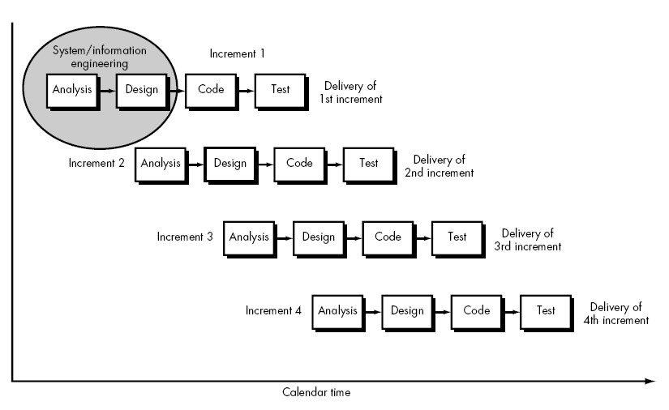

Fig: Incremental Model

Incremental model uses the following phases:

**1.Requirement analysis**

In this phase, analysis will be performed in order to find out the requirements of the system. The outcome of this phase would be a SRS which is an acronym for “system requirement specifications”.

**Functional Requirements**

**Logging in**

* The student shall log into the system by entering their username and password.
* The student shall use the account which was provided by the admin.
* After logging in, the student is directed to the homepage.

**Scan the QR code**

* After logging in, the student shall scan the QR code which will be provided by the subject teacher in order to do the attendance.

**Access to course content**

* Student can access the course content/ syllabus in the homepage.

**Feedback**

* Student can give suggestion about the system.

**Manage users**

* This functionality allows admin to maintain the system and add/remove/update the users

**Non-Functional Requirements**

**Usability**

* Simple to Operate: The software should be easy to learn and operate; the user should not require special skills or training to operate the system.
* Simple design: The user interface should be kept as simple as possible so as not to make the application too confusing for the user to understand i.e., user friendly interface.

**Reliability**

* The system should be up and running 24 hours and should be crash safe during its runtime.

**Security**

* As the system will be dealing with delicate data, the system should be secure. The data should be stored in a highly secure manner and should be immune from any hacking attempts.

**2.Design phase:**

In this phase, analysis of the SRS is translated into the system’s design. Context diagram, use-case diagram, ER diagram were developed.

**3.Coding phase:**

This phase involves the coding as per the design and formation of a working system at the end of the process.

**4.Testing phase:**

In this phase, the system is tested. With each testing, certain changes are made as per the suggestion. This is done in an incremental manner until a satisfactory system is made.

The different increments in our incremental model are:

**Increment 1:** Develop attendance modules

In this phase, several artifacts were produced which are as follows:

* Use case
* Context diagram
* System sequence diagram
* Activity diagram

**Increment 2:** Develop attendance system

In this increment, we analyze, design, code and test the system after the development of student and teacher panel.

**Increment 3:** Develop full integrated system

In this phase, we work on integrating the frontend system and backend system of the application. Certain changes were made in the system after testing. Overall system was tested and documentation were done in this increment.

**SYSTEM MODELS AND UML DIAGRAMS**

**Context Diagram:**

A context diagram gives an overview and it is the highest level in the data flow diagram containing process representing the entire system.

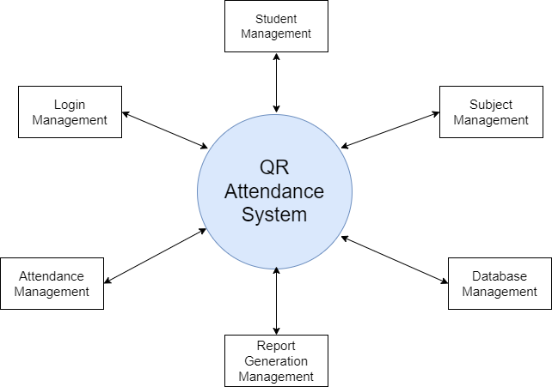

Fig: Data Flow Diagram

**Use case Diagram**:

The various actors of the system along with their functionality are described in the use case diagram below:

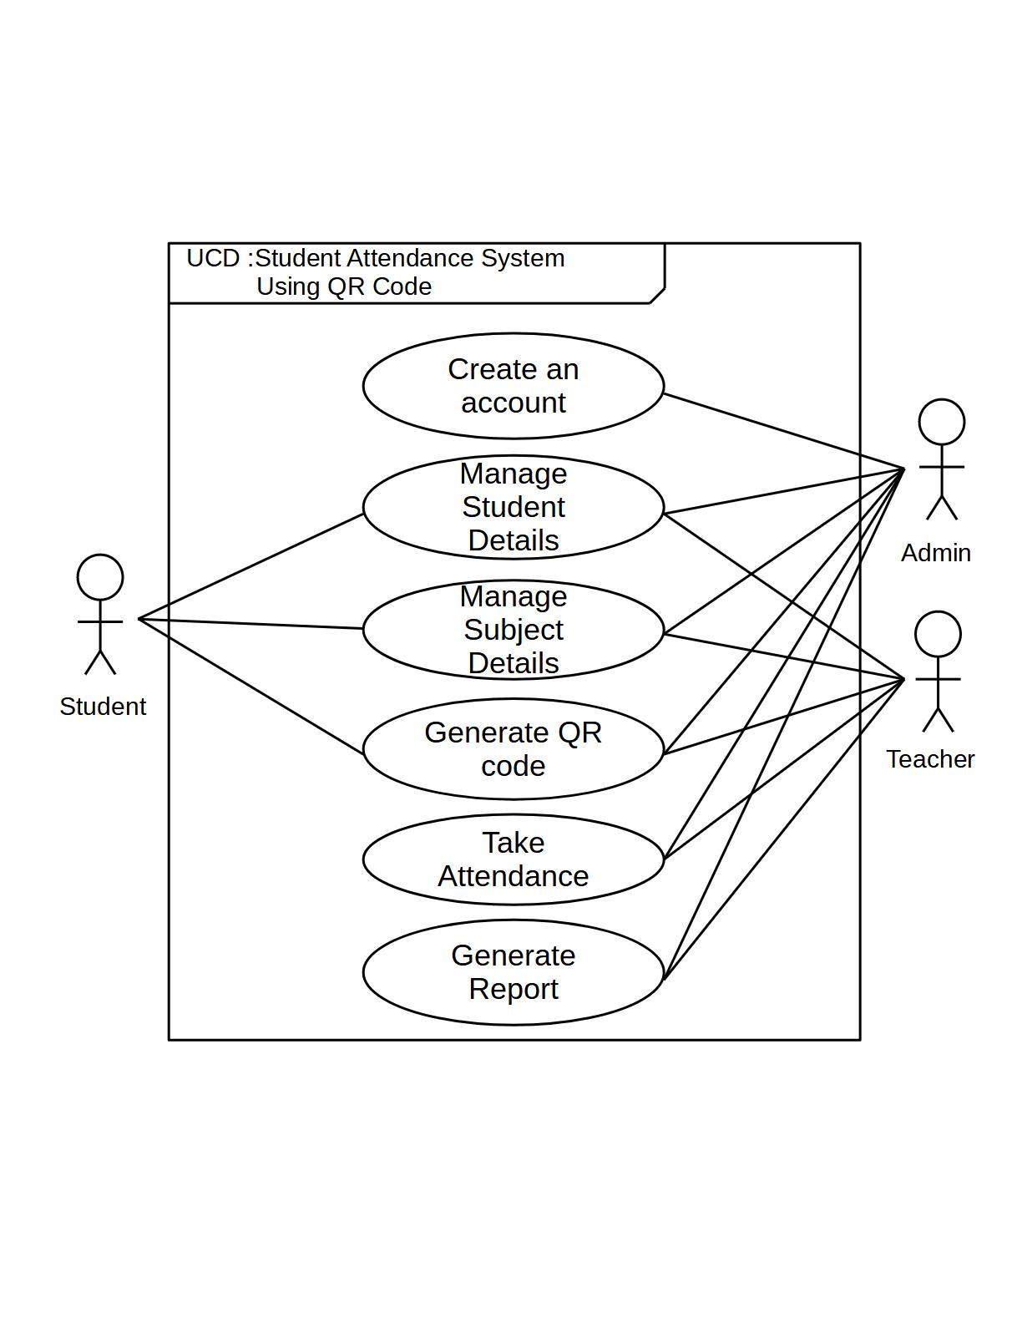

Fig: Use Case Diagram

Use Case Name: Create an account

Actors: Admin

Description: The Admin creates an account for every student with the mail provided by the college.

Use Case Name: Manage student Details

Actors: Admin, Teacher

Description: The student details is managed by admin and teacher. New students can be added, information is updated and deleted for enrolled students.

Use Case Name: Manage subject Details

Actors: Student, Teacher

Description: The necessary information about respective subjects is managed by the teachers.

Use Case Name: Generate QR code

Actors: Teacher

Description: Every lecturer generates different QR code for individual subjects. The generated QR code is only valid for respective subject and cannot be reused for another subject.

Use Case Name: Take Attendance

Actors: Teacher, Student

Description: Each students take their attendance by scanning the QR code which is generated by respective subject teachers.

Use Case Name: Generate Report

Actors: Teacher, Admin

Description: After scanning the QR code by the students, their attendance record will be stored in database and attendance report is generated which can be exported in excel format.

**Fully dressed use case**

Use case name UC2 – Scan QR

Scope – QR code Attendance System

Level - User goal

Primary actor – User/Student

Stakeholder and interest –

▪ Users wants fast and no error while doing attendance.

▪ Teacher wants students to make attendance using the email provided by the college.

Preconditions –

▪ Every time a new QR code is generated for every subject.

▪Students must be physically present in the class.

Success guarantee (Postcondition) –

▪ The attendance is saved in the system for a given user.

Main success scenario –

▪ The student scans the QR code provided by the teacher which is generated randomly for each subject and it is recorded in the system.

▪ The system sends back confirmation notification after the attendance is done.

▪ The system calculates the total attendees present within the class.

▪ The system saves the attendance.

Extensions/ Alternatives-

▪ In case of absence of the students, he/she can inform the teacher through message.

Special requirements

▪ Data must be persisted and stored in a database; the solution must be enabled for change of database suppliers fulfilling SQL standards

▪ The system must ensure average response time of few seconds.

▪ The language in the system must be English.

**8.3** **System Sequence Diagrams**

i) creating an account

Boundary Objects: User (primary actor)

User goal: create an account

System: QRAS

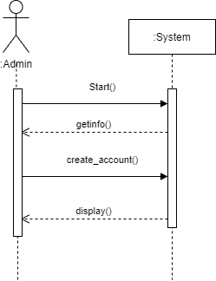

Figure: SSD for ‘creating an account’

ii. Managing Student Details

Boundary Objects: User (primary actor)

User goal: Manage Student Details

System: QRAS

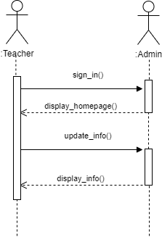

Fig: SSD for ‘Managing student details’

iii. Managing Subject Details

Boundary Objects: Teacher (primary actor)

User goal: Manage Subject Details

System: QRAS

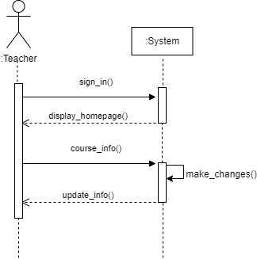

Fig: SSD for ‘Managing subject details’

iv. Generate QR code

Boundary Objects: Teacher (primary actor)

User goal: Generating QR code

System: QRAS

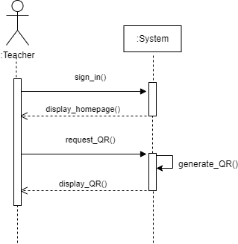

Fig: SSD for ‘Generating QR code’

v. Take Attendance

Boundary Objects: Student (primary actor), Teacher

User goal: Taking Attendance

System: QRAS

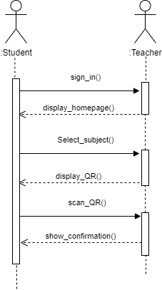

Fig: SSD for ‘Taking Attendance’

vi. Generate Report

Boundary Objects: Admin (primary actor), Teacher

User goal: Generating Report

System: QRAS

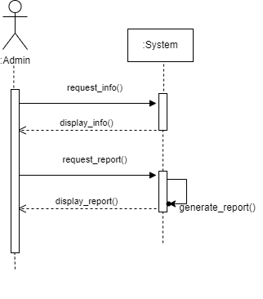

Fig: SSD for ‘Generating Report’

**Sequence Diagram**

Sequence Diagram is an interaction diagram which shows how the events occur and in what order. For our system, we have designed sequence diagram for most critical and influential activities which are shown below:

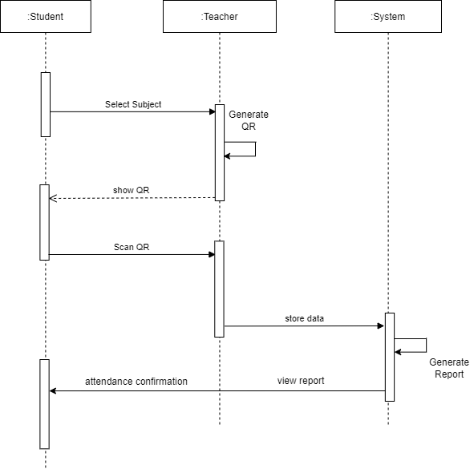

Fig: Sequence Diagram

**Activity Diagram**

Activity diagram is a flowchart to represent the flow of the system from one activity to another, which is basically the execution of steps involved in Use Case. This flow of control in a system can be sequential, branched and concurrent. Activity diagram is a behavioral diagram i.e, it depicts the behavior of the system. Activity diagram will have an initial state and a final state.

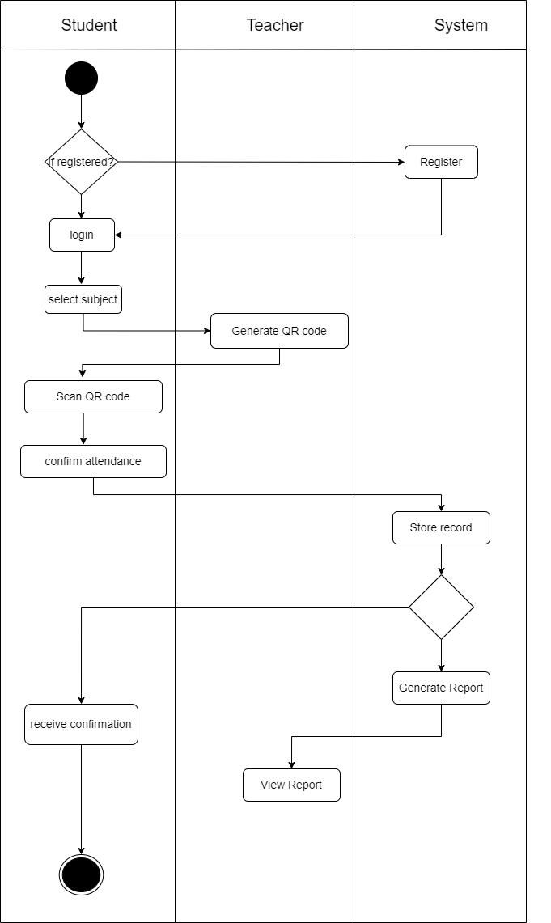

Fig: Activity Diagram

# Flow chart

The flow chart of the problem is shown in the figure below

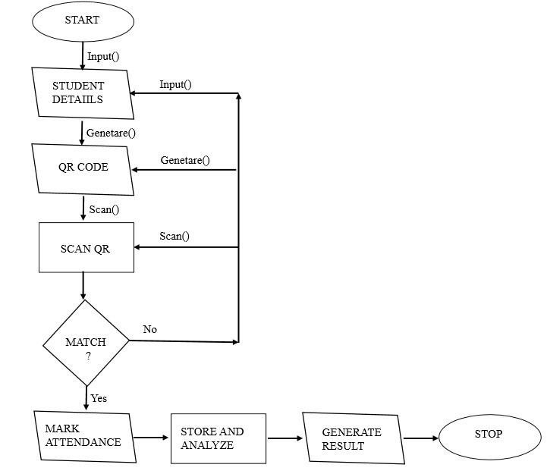

**TOOLS AND TECHNIQUES**

|  |  |
| --- | --- |
| PURPOSE | TOOLS |
| Frontend Development | Flutter version 3.3.7 |
| Design | Draw.io, Libreoffice |
| Backend Database | Firebase |
| Manage Source code | Github |

Fig: Tools Used

**USER INTERFACE**

The prototype Graphical User Interface Screens for the system is designed as shown below:

i) Login Screen:

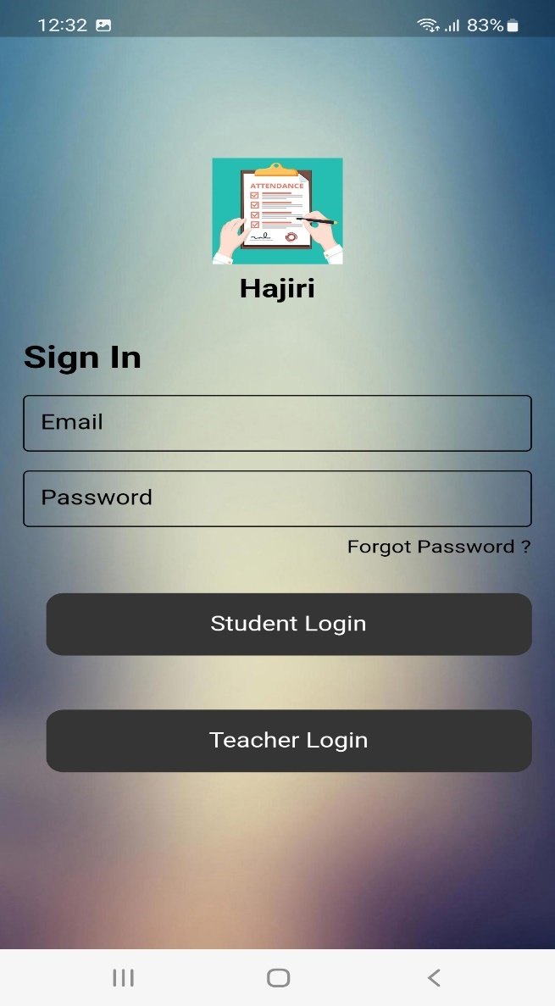

Fig: Screenshot of ‘login screen’

The figure above shows the login screen where each student can enter their email and password to login to their account. As only the registered accounts can login, teachers should create the account for the new enrolled students.

ii) Home Screen:

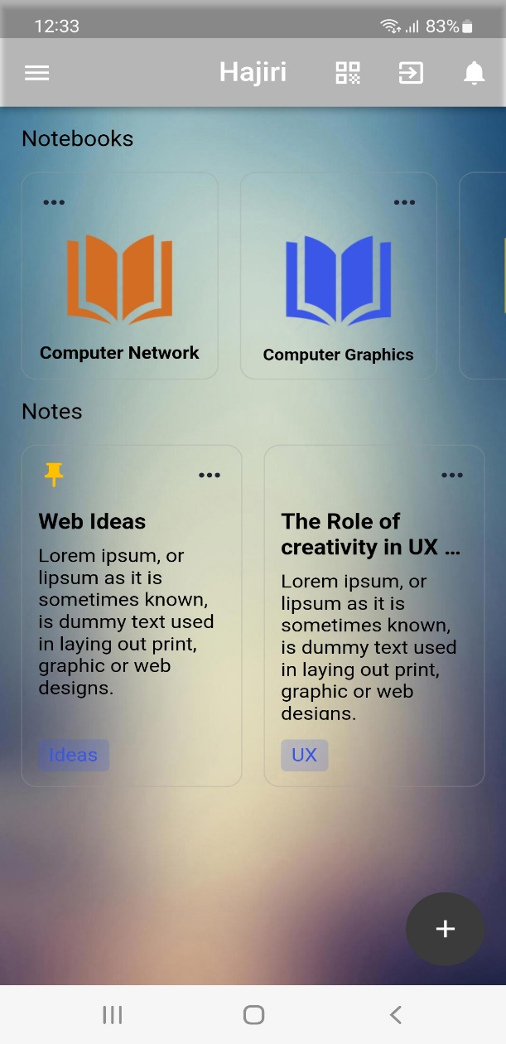

Fig: Screenshot of ‘Home Screen’

After logging in, you will be redirected to the homepage where you can see the options like course. Here, you can see the QR code scanning icon at the top through which qr code is scanned.

iii) QR code scanning:

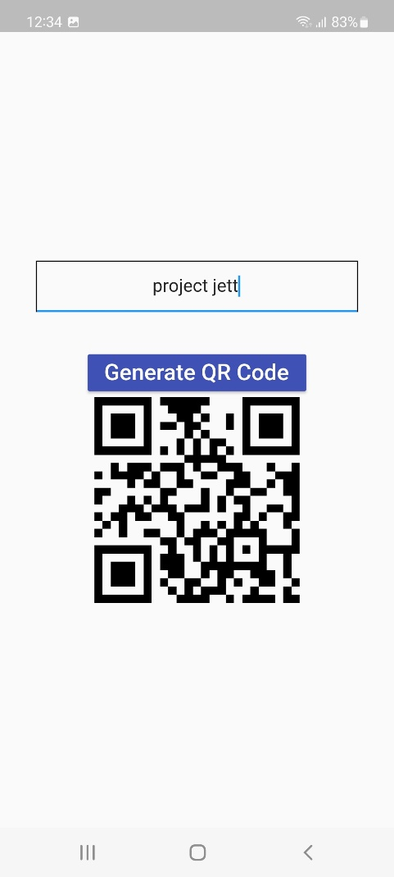 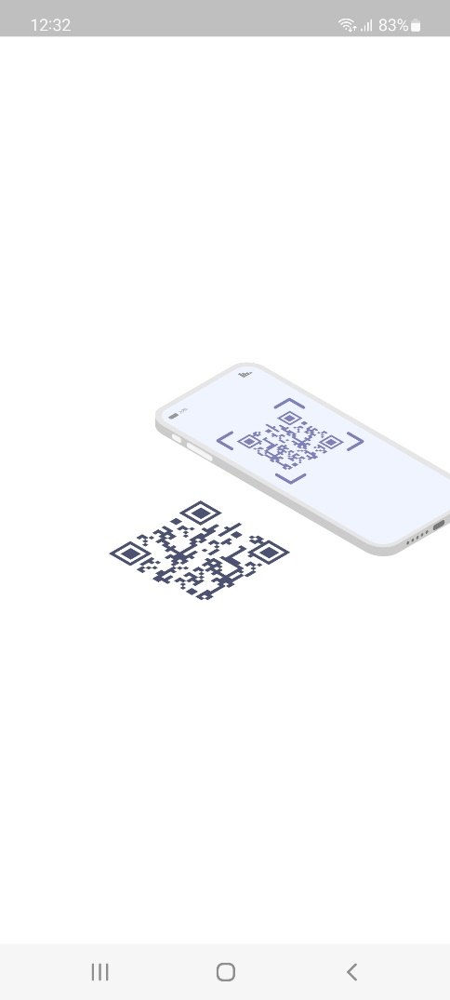

Fig: screenshots of ‘QR code scanning’

# TIME SCHEDULE

Increment 1

|  |  |  |  |  |  |  |  |  |
| --- | --- | --- | --- | --- | --- | --- | --- | --- |
| TASK | Day1 | Day3 | Day  5 | Day7 | Day 9 | Day12 | Day15 | Day18 |
| Requirement Analysis |  |  |  |  |  |  |  |  |
| System Design |  |  |  |  |  |  |  |  |
| Coding |  |  |  |  |  |  |  |  |
| Testing and Debugging |  |  |  |  |  |  |  |  |
| Documentation |  |  |  |  |  |  |  |  |

Increment 2

|  |  |  |  |  |  |  |  |  |
| --- | --- | --- | --- | --- | --- | --- | --- | --- |
| TASK | Day21 | Day24 | Day27 | Day30 | Day 33 | Day36 | Day39 | Day42 |
| Requirement Analysis |  |  |  |  |  |  |  |  |
| System Design |  |  |  |  |  |  |  |  |
| Coding |  |  |  |  |  |  |  |  |
| Testing and Debugging |  |  |  |  |  |  |  |  |
| Documentation |  |  |  |  |  |  |  |  |

Increment 3

|  |  |  |  |  |  |  |  |  |
| --- | --- | --- | --- | --- | --- | --- | --- | --- |
| TASK | Day  45 | Day48 | Day  51 | Day  54 | Day 57 | Day60 | Day  63 | Day66 |
| Requirement Analysis |  |  |  |  |  |  |  |  |
| System Design |  |  |  |  |  |  |  |  |
| Coding |  |  |  |  |  |  |  |  |
| Testing and Debugging |  |  |  |  |  |  |  |  |
| Documentation |  |  |  |  |  |  |  |  |

# CONCLUSION

The developed system presented in paper is successfully designed and tested. The student’s attendance status will be analyzed. Attendance monitoring system is very important in our daily life. It possesses a great advantage, among the whole types of code scanning technology, QR code based Smart Attendance System is the most accurate. In this project report, we have given an introduction of Attendance monitoring system and its advantage. It is an efficient method to store the attendance in the smartphone rather than wasting the paper.

# References

* *QR Attendance.* (2014, 02 08). Retrieved from Wikipedia: www.wikipedia.org/wiki/qr-attendance
* *Smart Attendance System*. (2014, 01 01). Retrieved from ResearchGate:
* *Software Engineering: A PRACTITIONER'S APPROACH, EIGHTH EDITION .* (2010).
* *Student Attendance System*. (2012, 4 5). Retrieved from Nevon Projects: https://nevonprojects.com/student-attendance-system-by-qr-scan/